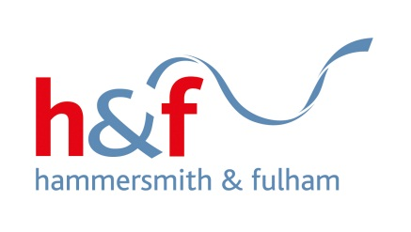
London Borough of Hammersmith & Fulham
Growth and Place
3rd Floor, Hammersmith Town Hall Extension,
King Street, London W6 9JU
Tel: 020 8753 2305 Mob: 07881 513 091
Email: getinvolved@lbhf.gov.uk
Web: www.lbhf.gov.uk



1 February 2021

Dear residents

A Chance to Bid for Free Improvements for your Estate!
Neighbourhood Improvement Project Consultation

We’ve received a Neighbourhood Improvement Project application from the Tenants and Resident Association (TRA) to improve the grassed area behind the estate.

The TRA would like to transform the grassed area into a space of peaceful enjoyment. Along with relaxing zen features, the application also proposed that this area has planters installed, where children and adults alike can learn how to grow vegetables.

The Neighbourhood Improvement Project (NIP) gives Hammersmith & Fulham council housing residents the chance to bid for environmental improvement works to their estate to the value of up to £30,000. For leaseholders, there will be no charge for any works done under this scheme.

Submitted bids are assessed by the Resident Involvement Team. Bids that meet the criteria are then presented to a resident-led group called the Investment Group, who review bid applications from across the borough and make the final decision on where funding is awarded.

Below you can see some pictures of the proposed space and on the next page is a drawing showing more ideas about the proposal.

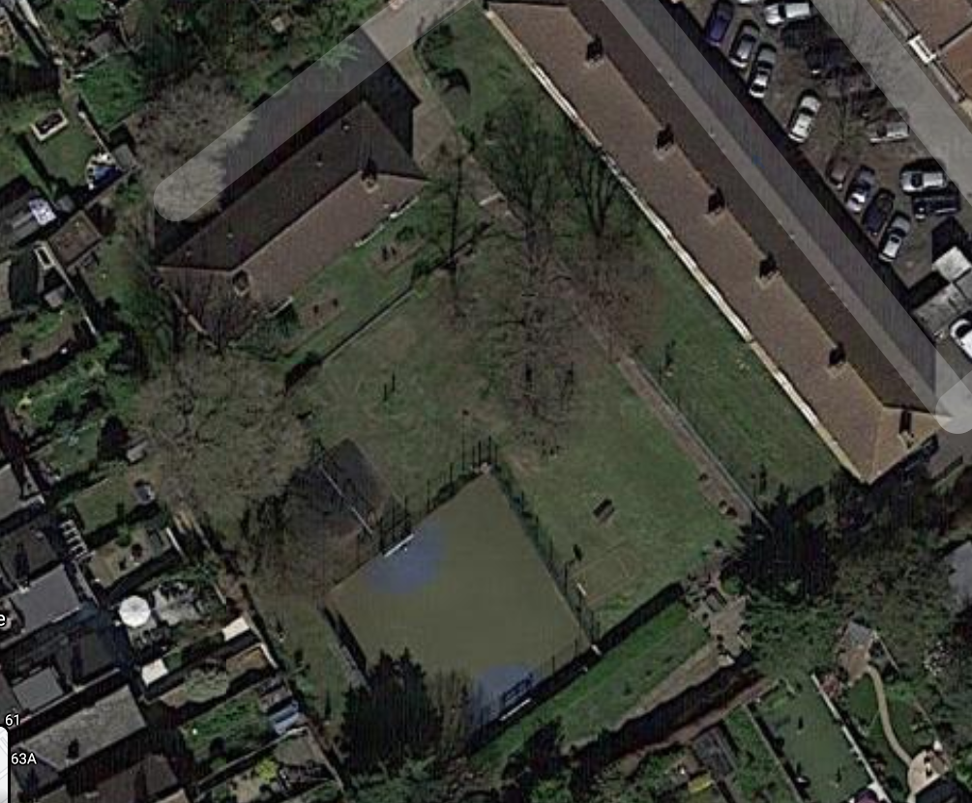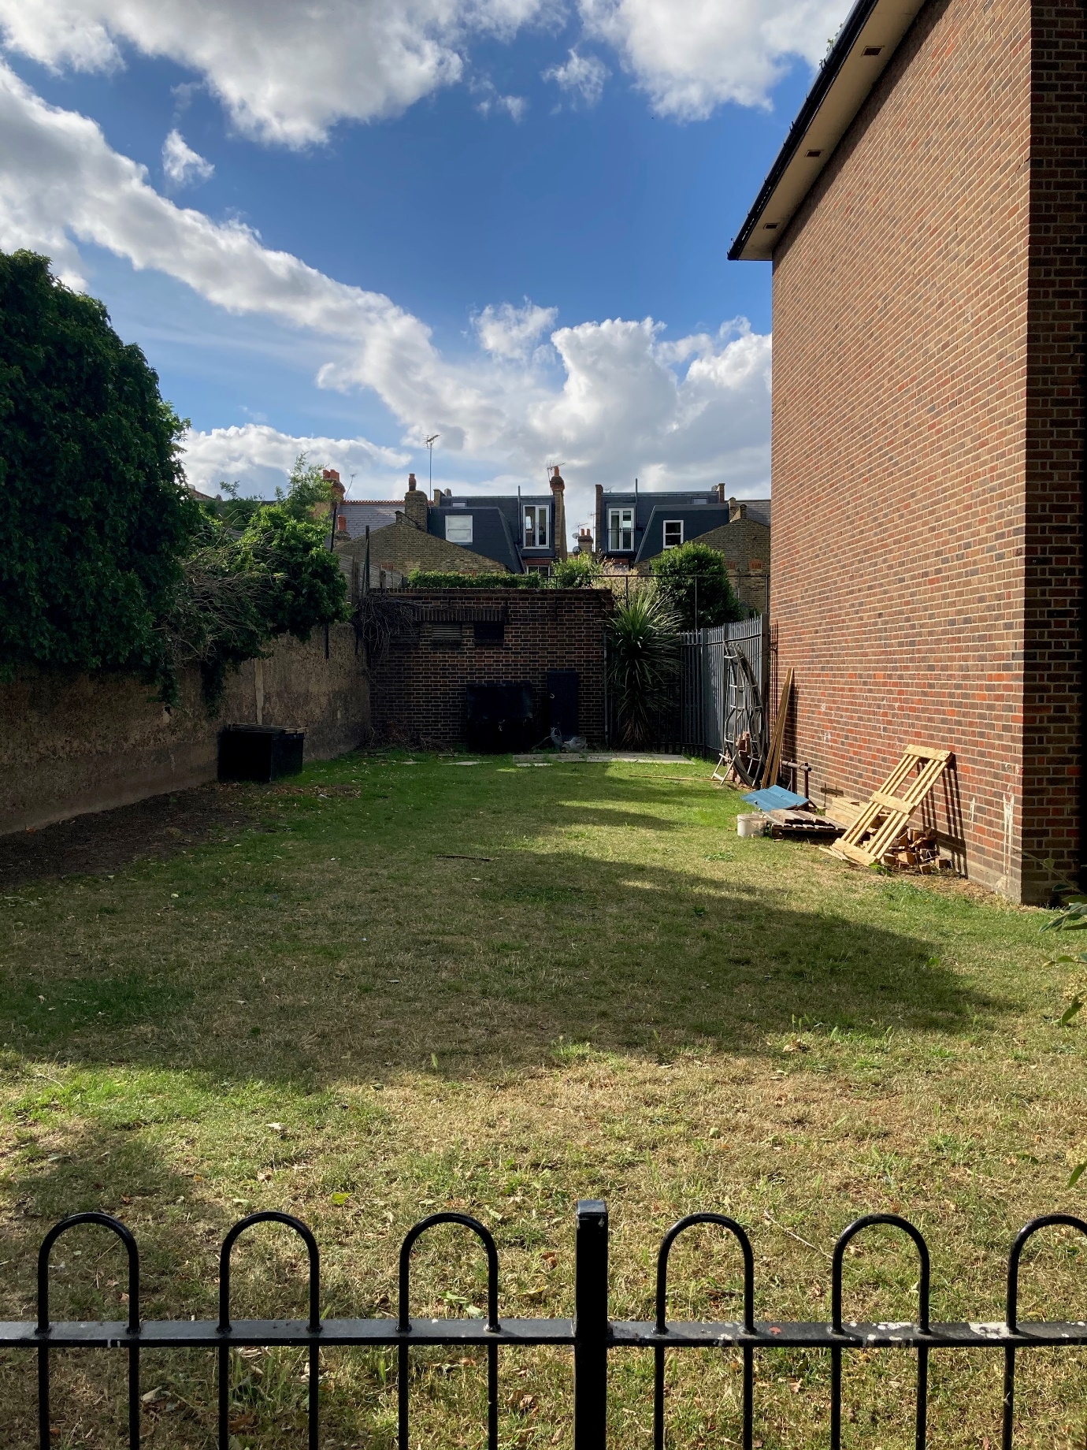

We’d like to hear your views on the suggested improvement of this grassed area. We also welcome any other suggestions you may have to transform this space into an area all residents can enjoy.

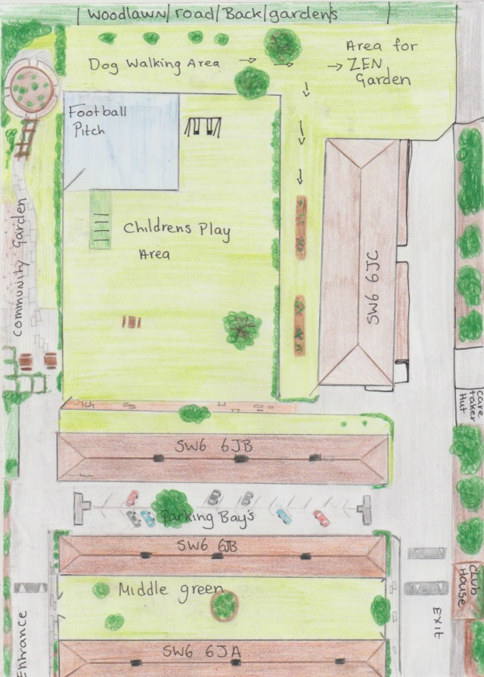

Please see below a couple of examples of what a zen garden could look like. As we are still in the initial stages of the process, we can explore different designs within the Neighbourhood Improvement Project budget.

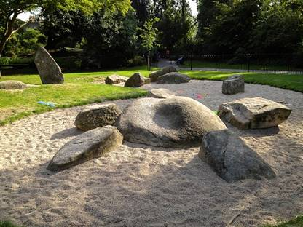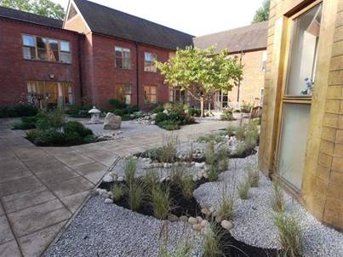

To support the application for funding (in time for the next Investment Group in March 2021), please can you complete the attached questionnaire and return it to me by Monday 15 February 2021, using the enclosed reply- paid envelope.

Your responses will be treated confidentiality and only the overall key outcomes of the consultation will be shared with the Investment Group.

The Resident Involvement Team will inform residents of the outcome of the funding application.

Thank you
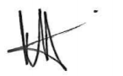

Magda Goncalves
Resident Involvement and Governance Manager
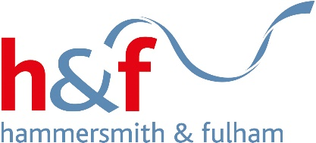


ROBERT OWEN HOUSE
RESIDENT CONSULTATION FEEDBACK FORM

Your Neighbourhood Improvement Suggestions
Let us know your preference...

Do you agree with the suggestions below? |  | Yes | No
Grassed area behind Estate | Installation of planters for residents to grow vegetables and teach children and adults how to grow food.
 | Creation of a small quiet Zen garden for activities such as yoga.

If you have additional suggestions, please include these below:

About you

Name
Address
Telephone
Email

Are you a…
(tick correct option)

Council tenant
Leaseholder
Private tenant

To enable this application to be processed it is necessary to ensure that the proposed scheme complies with Equalities Act and / or Care Act 2015 as may be applicable. Please answer the following questions:

 | Yes | No
Do you or a household member have Non-resident Carer who may be affected if the proposal was to proceed?

Are you or a household member Registered Disabled?

Do you have an advocate who represents you?

Sign up to the @Home e-newsletter to hear more about housing activities, events and news. This is emailed a maximum of 6 times a year and we would only send you a maximum of 2 other emails per month.
Please tick here to sign up

Please return this form by Monday 15 February 2021 using the enclosed freepost envelope. If you need help understanding and completing the form, please email getinvolved@lbhf.gov.uk. or call 0208 753 6652.
We will only use the information you provide to contact you about other improvements, ideas you have suggested, and the @Home newsletter, if you’ve told us you
want to sign up. We will not share your details with any third parties and any views that you have expressed will be anonymised and summarised in a consultation report

